**Wall-Mounted Black Metal Bar Shelf with Mirror**

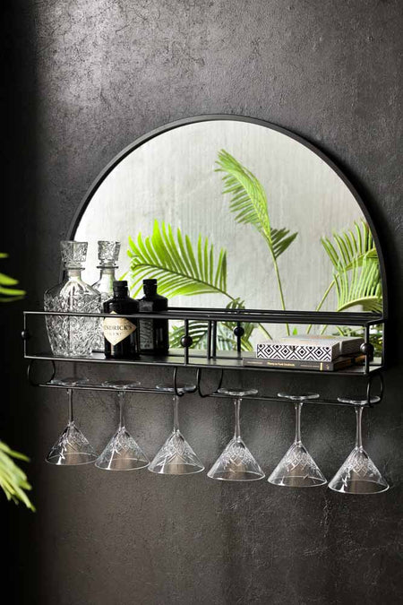The Wall-Mounted Black Metal Bar Shelf with Mirror is a stylish and functional piece of home decor that combines practicality with sleek design. Made from sturdy black metal, this shelf offers a modern, industrial aesthetic, making it a perfect addition to kitchens, living rooms, or home bars. The integrated mirror not only enhances the shelf's visual appeal but also adds a touch of elegance and depth to the space. Ideal for displaying bottles, glasses, or decorative items, the shelf provides both storage and a sophisticated surface for entertaining. Its minimalist design allows it to seamlessly fit into various interior styles, from contemporary to industrial or even rustic spaces. Whether used in a cozy apartment or a larger home, this wall-mounted bar shelf with mirror brings both utility and style, offering a chic solution for keeping your essentials organized while elevating the overall ambiance of the room.